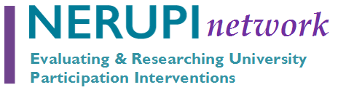
Using Data Dashboards for Information Management
As the range and scope of widening participation interventions become more complex the need for effective management systems becomes ever more urgent.
In this Evaluators’ Working Group session we will hear examples of two data dashboards developed to support planning, management, monitoring, evaluation and APP reporting of access, success and progression interventions.

Indicative Agenda
- 2.00 Welcome
Annette Hayton, NERUPI Co-Convenor
Annette will introduce the event and reflect on use of data management tools to support organisational-decision making on Access and Participation (APP) programmes.

- 2.15 Using dashboards for programme management
Jasmin Burnage, Impact and Evaluation Manager, and Nicole Alowoesin University of East London (UEL)
Jasmin is an education specialist with an interest in using data to drive access and success in post-compulsory education. She will share UEL’s experience of using dashboards for APP programme monitoring and cross-institutional insights.

- 2.35 Using dashboards to assess progress to evaluation framework objectives
Ayesha Siddique, Data Analyst for Evaluation and WP at Queen Mary University London (QMUL)
Ayesha has a background in using applied data analytics to inform strategic decisions. She will share the specific example of using purpose-built dashboards to generate evaluation insights from the use of pre-/post- feedback from participant taking part in APP activities.

- 2.55 Q & A

- 3.05 Discussion: From data to decisions: How do we ensure dashboards support meaningful decision‑making on access and participation?
The event will conclude with a discussion drawing on participants’ wider experience of the use of data management tools for APP work, limitations and best practices.

- 3.30 Close

Note: Organisational data and visualisations presented by colleagues as part of this event are shared on an in-confidence basis.

