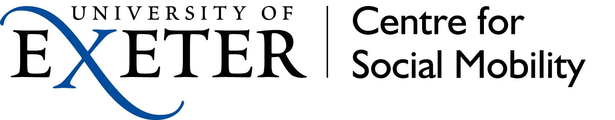Assessing the implications of school closure: Survey of

Uni Connect Partnerships and Widening Participation Professionals

# KEY FINDINGS

# Respondents were most concerned about student well-being and mental health at this time. The majority felt that students’ progression opportunities would be affected.

* Students without IT connectivity, those defined as ‘at risk’ and those who lack support at home were groups that the largest shares of respondents would like to see policy efforts focused on.
* Clearly there is a concern that students who lack access to resources and support will fall behind because, and that vulnerable students including at risk groups and many in low income households face additional risks due to their home circumstances. A fifth of respondents implied that the issues are local area-based.
* All but a small handful of widening participation professionals responding to the survey noted negative implications for their work: most prevalently postponement or cancellation of planned activities with groups of students and/or teachers. Changes in relationships and access to schools and learners were also noted, along with difficulties for planning and budgeting.
* Most respondents identified steps that are being taken or are in planning stage to support under-represented and / or disadvantaged students affected by the school closures. Increasing focus on online materials and a shift to online delivery of events being at the forefront of these developments. There were mixed views about the potential for these as they are largely untested and may not be accessible to those who need most support.
* Most respondents would like to see various types of direct support to students, parents and teachers, especially to help reduce inequalities in access to resources and connectivity and to promote well-being and emotional support.
* Suggestions for education policy include clarity on admissions processes and grade predictions; clarity on university admissions processes this year and grade predictions; continued support for at risk groups and those with additional needs including young carers; tackling inequalities in terms of internet connectivity and access to learning resources; promoting best practice/consistency in the ways that schools are maintaining engagement with students and how external providers including outreach professionals fit in.
* Suggestions for Universities include: creating or share curriculum / subject related resources which support learning; use of contextual measures and extenuating circumstances in university admissions. supporting applicants starting university; review the part-time offer.
* Suggestions for the Uni Connect programme included: clarity on expectations for the programme, including around the targets, data requirements and evidence required; security of budgets and an extension to the work programme; guidance on most useful interventions and approaches; co-ordination/joined up approach to online resources and information for students messaging to target schools and parents regarding engagement in the programme.

# Introduction

This study was designed as rapid response research. It aimed to assess the perceptions of widening participation practitioners in universities and Uni Connect partnerships on how the closure of schools as a result of the social isolation measures enforced due to the Covid-19 pandemic on 20th March 2020 will impact on young people in compulsory education, and affect the work of widening participation practitioners in supporting progression to Higher Education (HE). Little is known about the social, well-being, developmental, and academic consequences of school closure, although there are concerns that inequalities will deepen as a result particularly in terms of creating limitations on the functioning of state education as a force which, whilst not fully close socioeconomic gaps in children’s education, has some effective in reducing the magnitude[1]

The research aimed to describe and assess the effects of school closures, propose rapid policy interventions to mitigate any expected negative effects, and to describe recommendations for the widening participation professional communities.

## Methodology

Ethical approval was received from the University of Exeter to undertake this survey. A questionnaire survey was designed collaboratively by a working group established for the project, which was comprised of academics and associates of the Centre for Social Mobility at the University of Exeter. Data was collected via an online survey in two ways:

* A call to Uni Connect professionals, disseminated directly to Uni Connect evaluation leads and running between 25th March – 14th April 2020.
* An open call to Admissions, Widening Participation, Outreach and Student Recruitment professionals in universities, distributed via direct approaches using databases and via social media networks, running between 28th March - 20th April 2020. Respondents could opt to participate in a £50 prize draw or a donation to ChildLine for completed surveys.

## Data analyses

The data was cleaned and duplicates or unuseable responses were removed. Responses to closed questions were analysed in the first instance using basic descriptive statistics. In order to analyse open-ended questions whilst ensuring consistency, qualitative data was coded manually by one member team member.

## Limitations of the study

Because the focus was on making a rapid response to the emerging developments the research was undertaken at a time when responses to school closures were in the early stages of development, and therefore may not reflect the picture over time. The surveys were promoted through an open call and there is potential for a small amount of duplication. The responses are not representative of the HE sector in terms of the profile of HE providers and widening participation professionals. There is likely response bias in terms of respondents with particular concerns or perspectives might be more likely to engage. There is also a potential skewing effect since multiple responses were made by professionals in different roles within the same institutions. As far as possible the researchers sought to mitigate overlaps by targeting the surveys at different audiences, removing duplicate responses, undertaking discrete analysis of the datasets separately, or removing known duplicates from combined analyses. The survey did not seek to be representative of the sector as whole but rather sought to highlight key issues and concerns and point to the potentially useful policy and practice recommendations to promote widening participation to higher education at this unprecedented time.

## Responses received

Collectively the surveys yielded 262 responses across a fairly wide range of different widening participation professional groups and organisations as shown in Table 1. Professionals working in Uni Connect partnerships represented just under half (46%) of respondents. Amongst university-based respondents, professionals in Russell Group institutions were the next largest group (around a quarter of all respondents and over half of university-based respondents). Respondents were groups according to their job role (free text). The majority of respondents described their roles as officer roles that appeared to relate to the delivery of widening participation/outreach interventions at project or programme level. Around a fifth were leading or managing programmes or projects. Just over one in ten had a specifically data or evaluation role (mostly in a Uni Connect partnership). Some people in roles related to admissions, recruitment and careers/employability also took part. However this analysis is based on a brief description and there is likely to be some overlap between many of these functional roles in practice.



# Views on the impact of school closures on students

The sense emerged that respondents felt that the effects of school closures is likely to cut across all groups of students, although students who already face disadvantages will be hardest hit. In terms of the impact of the school closures for the students targeted as part of Uni Connect partnerships, Uni Connect professional respondents were most concerned about the well-being and mental health aspects. However, there were relatively high levels of concern (around 4 out 5) across many aspects, including concern about the long-term prospects for Uni Connect students (3.8 out of 5 on average).



Widening participation professionals were mostly likely to identify students without internet access/IT connectivity, those defined as ‘at risk’ and those who lack support at home as the groups most affected by school closures. These are groups that the largest shares of respondents would like to see policy efforts focused on.

The comments indicate that there are major concerns for the safety and well-being of at risk children, because of the risk of abuse, exploitation, poor mental health, self harm, risky behaviour/ falling victim to crime or being dragged into it themselves). Added to this, children at home who were previously not at risk may develop into being at risk without services knowing (due to not being at school and therefore with less chance for professionals to notice changes of behaviour and so on).

*“This trauma WILL be happening but these students now have no safe haven as schools are closed and support systems are remote - privacy and confidentially may not exist.”*[Uni Connect evaluation lead]

Just under half (47%) would like to see policy efforts focused on students who have less support for home schooling. Many comments implied that a lack of home support was more likely for students in the other disadvantaged groups. The comments also suggest that lack of home support may coincide with other issues, such as lack of space for study for students in over-crowded households.

Students who lack access to the internet came out as a policy priority for 46% of respondents. Several respondents mentioned issues to do with a lack of IT equipment generally as well as the connectivity issue. Clearly the concern is that these students will fall further behind other students because they will not be able to access work that is being set by teachers (and comments suggest even if they are sent printed versions, may not have the resources or support to complete it). Missing out on the social aspects of school, such as interacting with other students and friends, may also affect some students socially and educationally more that others. Concerns were expressed for estranged students who may risk feeling very isolated and vulnerable during this time.



Around a third of respondents would like to see policy efforts focused towards Free School Meals eligible students. The comments highlight concerns that educational and emotional resilience, as well as levels of support, are lower for students in low income households compared to their more advantaged peers. The potentially wide range of problems facing those in households with low income were mentioned, from lack of adequate food or nutritious meals, as well as insecure housing, and increased pressure on families to continue working making carers of these students more distant and less able to provide educational and emotional support, and also increasing the risks of their families direct exposure to the Covid-19 virus and it's associated potentially devastating consequences.

*“I'm worried about our assumption that all learners have access to mobile technology, and a space and the support to access resources. While not all schools are created equal, there is at least something to be said for the school day providing structure and support to students.”*[Widening Participation Officer]

A fifth of those who responded would like to see policy efforts focused in areas of low higher education participation (LPN), as a proxy for students in the most deprived areas. It was clear that most respondents expect relative disadvantage to be neighbourhood related, and that those in areas scoring the worse on indicators of social and economic disadvantage including higher education progression are more likely to fall into the priority groups identified above. Economic disadvantage does not just raise issues to do with access to educational resources and support (including internet access) but other important requirements related to getting adequate daily nutrition, mental and emotional support and safety. The sense also emerged that students who are young carers will be under additional pressure at the current time, and well over a quarter of respondents saw this group as a high priority. Other people noted that extra pressure is also put on children in families with English as a second/additional language as they are often relied on for translations and supporting essential households tasks such as shopping.

*“I worry that the ‘summer gap’ we see between the most and least deprived children when school is in a ‘normal’ academic year will only get worse during this pandemic.”*  
[Widening participation officer]

Amongst other groups affected by school closures, students in the transition stages of education (Years 11 and 13) were most often mentioned by Uni Connect respondents. A range of issues was raised: not only those associated with grade calculations for those who have cancelled exams, but also missing out on progression/transition support in the summer term. Several comments point to concerns that the aspirations of students who don't have a family background in higher education may be influenced against higher education progression because of negative attitudes of their families or because they are under pressure to support the family economically. If grade predictions are used as a basis for admission to courses, state educated students in state education will be adversely affected because teachers have been shown to under-predict students.[2] Issues were also raised in relation to the higher education progression opportunities for some specific groups, notably students who aspire to enter medical education as lack of access to work experience opportunities, may be exacerbated in the current climate.

# Implications for widening participation to higher education activities

All but a small handful of respondents said there were negative implications for their work, and most prevalent implication being postponement or cancellation of planned activities with groups of students and/or teachers. Overall, at least eight of ten respondents in all the types of universities said some activities would no longer be possible during this period, and around seven out of ten respondents in Uni Connect partnerships. One Uni Connect partnership respondent said 182 events had been cancelled so far. Where events have been postponed, knock on effects were noted for the future (for example a Uni Connect practitioner said much of the work they have spent the last 4 months planning is now postponed and finding new dates, re-booking events etc will take time from the work that would have started in September.

Interruptions to the provision of individual support to students was also fairly prevalent problem for Uni Connect practitioner respondents – mentioned by 44% - although less of a concern for those in universities (12% of respondents).

A third of respondents mentioned other issues for their work. Of these, the largest group (28%) spoke about problems related to disruption in communications or relationships with schools and teachers, including schools having competing priorities. Some 16% mentioned issues around the ability to collect data or evidence on participants, and a further one in ten felt follow-up/tracking would become more problematic. Issues around uncertainty for budgets and finance were mentioned by 15%. Some people were concerned that unspent funds would be clawed back, meaning less resources to make up for lost activities. A practitioner in an university said widening participation funding was under threat due to claw back fro the centre to protect essential services. A Programme lead in a Uni Connect partnership commented that some schools have used forecast budget to support Uni Connect students to learn at home and provide equipment, or for food vouchers, which means little or no outreach budget is left for the summer term if schools re-open before the end of July.

Problems associated with difficulties in planning activities, given the uncertainties surrounding the pandemic, were mentioned by 14%. Plus, a further 13% said they anticipated issues associated with recruitment or engagement of students in the near future, not just because school priorities may change but also because they may be unwilling to commit to activities which risk future cancellations or restrictions due to social distances. A Uni Connect Programme lead commented that although they are planning activities in August to support students with the transition back into education in September, there is a concern about how much schools will shut down next year in terms of allowing students out.

*“The summer terms are a time where there is significant engagement due to schools dedicating time to personal development and for Y12 students its a crucial time to support them in exploring HE options. It is not just the events that have already been cancelled but it is the uncertainty of what comes next, whether schools will reschedule cancelled activity or just move on to the next activity leaving a gap for some students. Also if there is significant catching up to do in terms of the curriculum it could have a knock on impact on the engagement schools have with the project.”*[Widening Participation Liaison Officer]

Other issues noted included problems for delivery associated with staff members leaving or being furloughed (and concerns about future recruitment especially in relation to time-limited programmes), alongside other problems for teams such as having to deal with new working arrangements and the stress of the current situation.

# New developments in widening participation to higher education activities

Most respondents identified steps that are being taken or are in planning stage to support under-represented and / or disadvantaged students affected by the school closures. Increasing focus on online materials and a shift to online delivery of events being at the forefront of these developments.

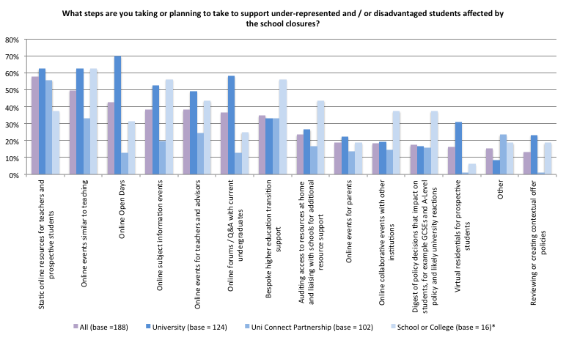*\*Caution low base*

Seven out of ten respondents who are in university widening participation and related roles said that open days would be offered online, and over six out ten said their universities were offering online events similar to teaching, and static online resources. Online open days were a feature across all types of institutions. Respondents in Russell Group institutions were more likely than those in other types of institution to offer static online resources (67% of respondents in Russell Group institutions said this compared to 57% and 53% in Post-92 and other institutions respectively). Over half (53%) of all university respondents spoke about online subject information events, and just under half (49%) were offering online events for teachers and advisors. Online forums / Q&A with current undergraduates featured for 58% of university respondents overall, and respondents in post-92 institutions were most likely to say this (74%). More respondents in the post-92 and other types of institutions were offering bespoke higher education transition support compared to those in Russell Group institutions (44% compared to 23% of respondents in Russell Group institutions). Around two-fifths in Post-92 institutions (39%) and a quarter in other types of institutions (24%) were offering online events for parents, compared to 14% of respondents in Russell Group institutions. Virtual residentials featured more highly for respondents in Russell Group institutions (44%) compared to only 17% of respondents in other institutions. Respondents in the ‘other’ category of universities were most likely to say they were reviewing or creating contextual admissions policies (41%), well above twice the share of respondents in the Post-92 and Russell Group institutions.

*“Online resources/support particularly targeted at underrepresented groups. Ensuring all support is mobile friendly, as many learners do not have access to computers.”*  
[Evaluation lead]

Respondents working in Uni Connect partnerships were most likely to point to the provision of static online information. Signposting to other sources of information and online resources/activities, comes out as of key importance for this group, as well as the direct provision of information. It was clear from the comments received that Uni Connect partnerships have the ability to bring together key stakeholders to coordinate the support that is being offered during, and want to make sure resources are shared effectively and limit duplication. There was a sense that collaborative partnership in higher education Outreach Hubs including schools, colleges, careers providers, and others such as local authorities and local enterprise partnerships have the ability to work together to keep information advice and guidance to students (IAG) a priority during this time. There was also a focus in terms of supporting the well-being of students and offering advice to support motivation and independent learning. Around a third of Uni Connect respondents pointed to planning for online outreach activities, to be offered through school partnerships, or direct to students. A couple of Uni Connect respondents identified moves to distribute physical activities and resources to the target learners (e.g. workbooks). A fifth said they anticipate online events for teachers and advisors. Bespoke higher education transition support was a feature for around a third. For example one senior leader spoke about personal phone calls for pupils in year 11 or 13 about choices for the next year and futures. Other aspects of the Uni Connect offer mentioned by respondents included online mentoring or tailored support via email. Overall, around a third aimed to continue to offer bespoke transition support. A Programme Leader in a Uni Connect partnership said although they are using a range of alternative ways of working with schools and students, the uptake/engagement of students in this this offer may be limited as school leaders are dealing with more pressing issues.

*“Support already being provided through online resourcing (with much emphasis on wellbeing). However, not easy to communicate that directly to Uni Connect cohort.”*[Widening Participation Officer]

Although the sample base is smaller for schools and colleges, the responses from this group suggest that efforts her are most likely to be directed towards online subject information activities, bespoke education or transition support, and online activities for teachers and advisers. Over four in ten said they were auditing students’ access to resources at home and liaising on this issue. Well over a third of respondents said they were providing information on policy decisions affecting students. Decisions around exams featured highy here.

On a positive note, several respondents were optimistic that developments taking place now out of necessity may create new working models for the future. For example, one Widening Participation Officer commented that the current situation has opened new channels for communications with schools and telephone conversations have taken on a more personal touch, which will perhaps benefit relationships going forward. There were mixed views about the potential effectiveness of online delivery. Some respondents felt that online delivery methods, although as yet untested, may prove beneficial. A Uni Connect practitioner noted that although schools’ focus initially wasn't on engaging with the partnership, after a few weeks they received feedback from school contacts that the work being provided as either resources or online activities has been beneficial for their students. On the other hand issues regarding access to students were raised. An Engagement Officer working across two schools said information is harder to get across without knowing whether it is understood, advice is difficult when not face to face, and guidance has similar problems. Activities are harder to make engaging and fun online which, coupled with the necessity of students actually logging in online, potentially reduces the incentive to participate in Uni Connect programme activities.

# Support from policy makers

Types of direct support for students were most mentioned by respondents in relation to support from policy makers to help them to improve outcomes for the students most negatively affected by the impact of school closures, particularly supporting well-being and providing additional support for those falling behind. A majority would like to see support to tackle differentials whether in relation to internet access, learning resources, or necessities. Just under half were in favour of prioritising increased SEN support at home. The majority of respondents would like to see support for teachers in relation to online delivery, and a large minority welcome support for teachers re-transitioning students into education and providing emotional support.

Well over two-fifths thought changes should be made to contextual measures and extenuating circumstances in higher education admissions. Regular updates on university admissions along with guidance on grade predictions stand out as key measures many respondents would like to see to support higher education transition at this time.

*Clear and concise messaging to pass to schools and students about HE progression and the UCAS process this summer.*[Widening Participation Officer]

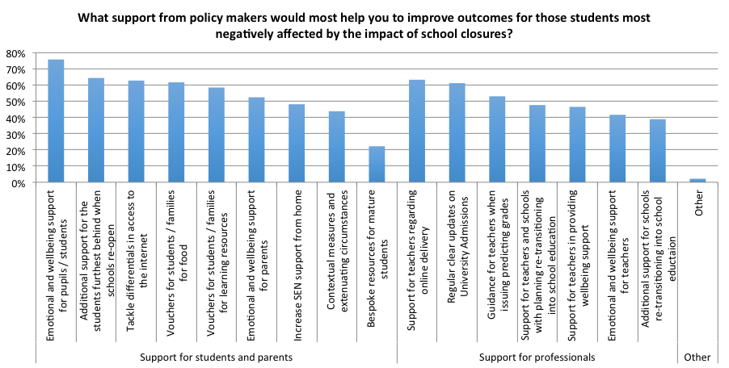

Clarity and security in relation to funding arrangements and budgets, and/or an extension to the programme in order to make up time and enable more sustained evaluation featured highly amongst suggestions for support from policy makers that would help to Uni Connect professionals to do their work.

Uni Connect respondents would like to see direct support for Uni Connect target groups and their parents via information and guidance, particularly on university admissions. One Programme Lead said Uni Connect Y13 and Y11 students (and their parents) need specific messaging to reassure them that their specific circumstances will be taken into consideration. Some respondents felt the OfS should have a role in co-ordinating a national response to online information and guidance, and targeted online activities, in order to avoid duplication, guard against over-load and provide more consistency. Some practitioners would welcome guidance on understanding what the aim should be in this period, and what types of delivery should be considered most be useful. Messaging to schools regarding expectations for engaging with external support an partnerships would also be welcomed.

*“I would like to see an offer of a national programme of online activities/events/webinars that students and parents can access during this time which can help to prepare for the next step.”*[Uni Connect practitioner]

Suggestions for information or steps from policy makers which Uni Connect respondents think would have a positive impact on their ability to do their evaluation work centred calls for the OfS to clarity the expectations for Uni Connect partnerships in terms of delivery and implications for targets at this time, and/or offer some guidance about the types of interventions and information partnerships might be expected to deliver and expectations for monitoring and tracking purposes/information required. There were calls for improved access to pupil level administrative and guidance on how to approach GDPR under new working condition (including specifically, messaging around use of public task and reassurances to schools/colleges that this was a requirement). Some people would like OfS to adjust expectations of 'success' of the programme given Covid-19 may have negatively impacted upon higher education progression for the target groups, and there may be value in focusing on live experiences.

## Suggestions for education policy makers include

* Clarity on university admissions processes this year and grade predictions, with reassurances to those currently in the transitional stages of education.
* Making sure support continues for at risk groups and those with additional needs including young carers.
* Tackling inequalities in terms of internet connectivity and access to learning resources.
* Promoting best practice/consistency in the ways that schools are maintaining engagement with students and how external providers including outreach professionals fit in.

## Suggestions for universities include

* Share clear and accurate guidance to support their applicants starting university, with a view to reducing concerns and worries.
* Create or share curriculum / subject related resources which support learning.
* Use of contextual measures and extenuating circumstances in university admissions.
* Consider the part time offer, taking into consideration that finance will be an even bigger concern for some during this time and some learners may now prefer to work and study part time to bring income into the home.

## Suggestions for Uni Connect programme include

* Security of budgets and an extension to the work programmme.
* Clarity on expectations for the programme, including around the targets, data requirements and evidence required.
* Guidance on most useful interventions and approaches.
* Co-ordination/joined up approach to online resources and information for students.
* Messaging to target schools and parents regarding engagement in the programme.

Authors: Joanne Moore* and Anna Mountford-Zimdars**

* Research Fellow, University of Exeter, **Professor of Social Mobility, University of Exeter

Some data collection was supported by an OfS commissioned project/contract.

For further information on the University of Exeter Impacts of School Closure survey please see: https://www.exeter.ac.uk/socialmobility/projects/

1. Raudenbusch, S. W. and R. D. Eschmann (2015). “Does Schooling increase or reduce social inequality?” Annual Review of Sociology 41, 443-70.
2. Wyness, G. (2016) Predicted grades: accuracy and impact. London: UCU.