HEAT User Guides: Using HEAT with NERUPI

Q. Who is this guide for?
A. All HEAT members who subscribe to NERUPI.

This guide will show you how to code activities to the NERUPI framework and then report on these activities.

Please note: This guide requires institutions to set up custom data fields. Only HEAT Coordinators or Custom Roles where Add Custom Data permission has been given are able to do this.

Creating custom data fields to record the five NERUPI aims
Reporting on the NERUPI aims

In order to report on the NERUPI framework through HEAT, institutions must first create custom data fields in the Activities tab. Custom data fields enable institutions to record data that is specific to their own data requirements. In this guide these fields will reflect the five NERUPI Aims, however, you could create fields to reflect the NERUPI Levels or NERUPI Objectives.

Creating custom data fields to record the five NERUPI aims

- Log in to the HEAT database
- Select My HEAT from the options listed in the left-hand menu

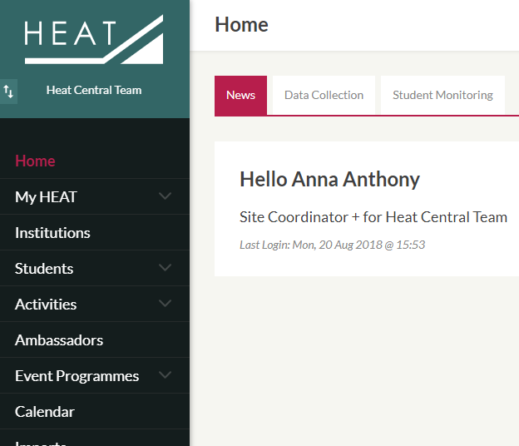

- Select Custom Data from the options in the left-hand menu

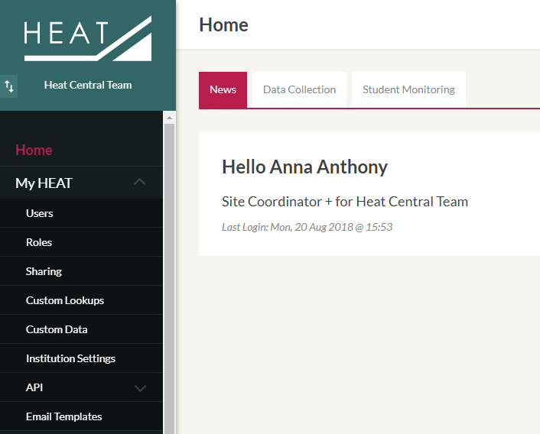

- Select Add Data + from top-right-hand corner of screen

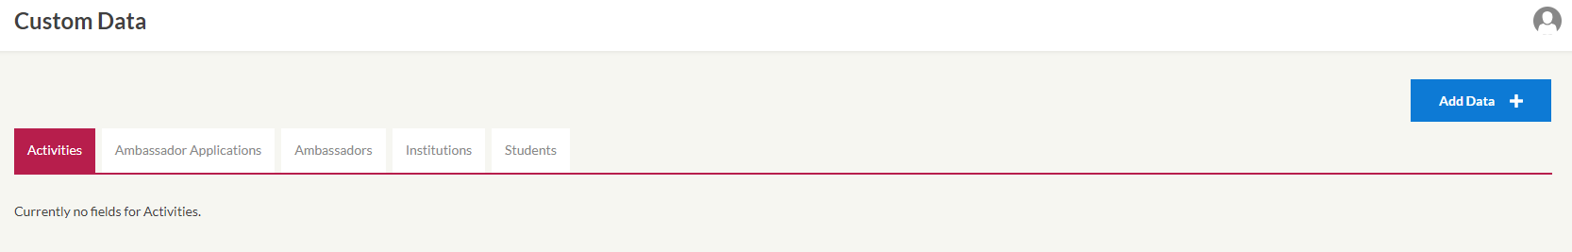

- In the Entities drop-down box, select Activities
- In the Identifier free-text box, type KNOW
- In the Type drop-down box, select Yes/No/Unknown
- In the Section free-text box, type NERUPI
- If you wish to write a brief description of the NERUPI Framework for users you can do this in the Section Description text box
- In the Label free-text box, type KNOW
- Leave the Required checkbox unticked

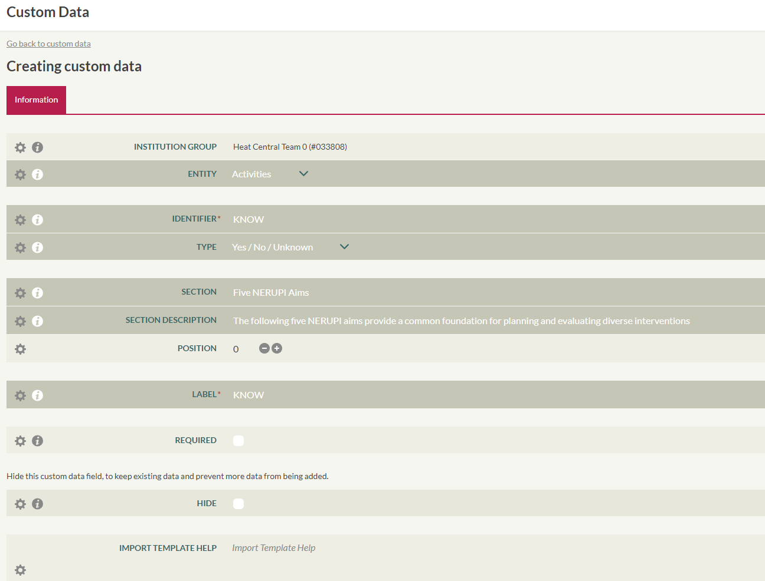

- Click the Save Changes button in the top-right-hand corner of the screen

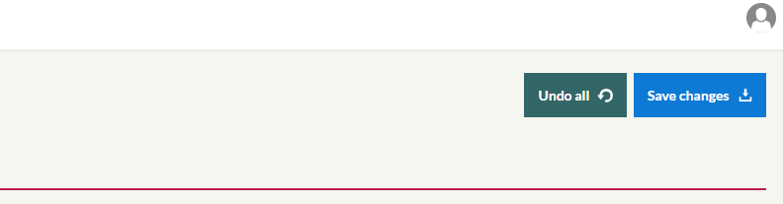

Repeat this process with the remaining four NERUPI aims: CHOOSE, BECOME, PRACTISE and UNDERSTAND. Please ensure the text in the Section and Section Description free-text boxes match exactly when setting up each aim (HEAT saves the text entered for the first aim so this can be selected next time).

The five NERUPI aims can now be seen in the Custom tab when creating a new activity or in an existing Activity record. You can now start coding your activities in accordance with the NERUPI framework.

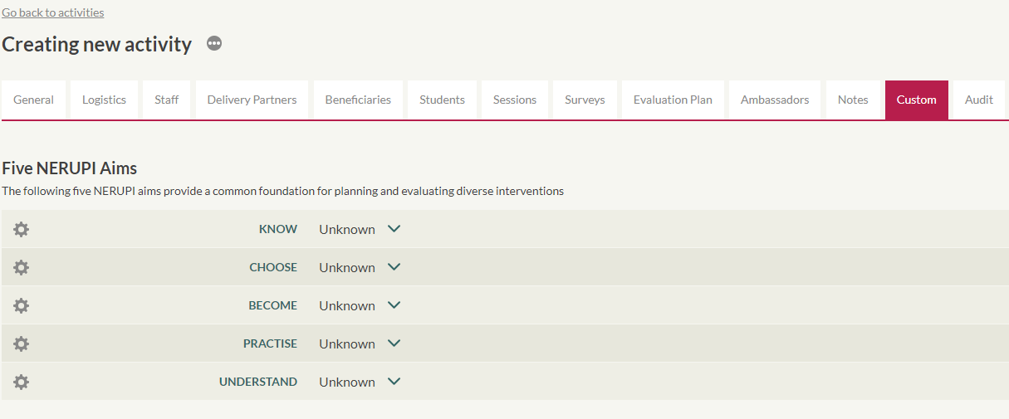
For ease of reporting, select Yes where an activity aligns with that aim (you may select more than one) but leave those aims that do not apply as the default Unknown, rather than selecting No. This will mean those fields appear as blanks in the data export.

Reporting on the NERUPI aims
The standard HEAT Delivery Report does not currently report on Custom Data fields, however, data can easily be exported into an Excel spreadsheet for manipulation.

Please note: HEAT’s guide on Filtering and Exporting will be useful prior reading for those unfamiliar with isolating and exporting data from HEAT before manipulating in Excel.

The following bullet points and screen shots provide an example of one way to report on NERUPI data exported from HEAT in Excel.

- Exporting activities will allow you to count the number of activities delivered falling under each of NERUPI’s aims, with each of NERUPI’s five aims appearing as separate columns in your data (see example below)

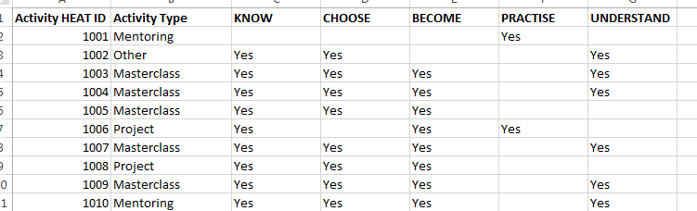

- Setting up a Pivot Table as shown below will allow you to count the number of activities recorded under each NERUPI aim (grand total row)
- Placing another activity variable in the Rows section of the Pivot Table will create a crosstab whereby data are further broken down (Activity Type has been used in the example below)

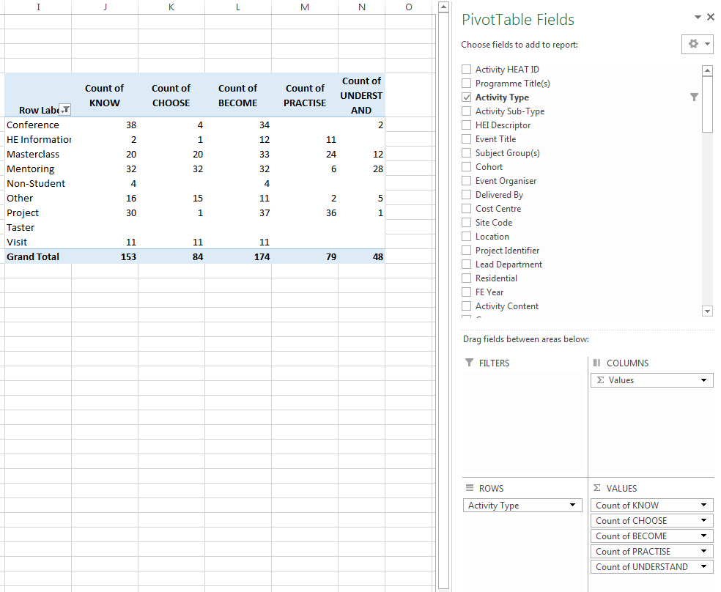

Please note: The export will need to be saved as a csv file rather than an Excel file in order for the Pivot Table to recognise the blank cells required for the calculations in the previous screenshot.

- The total estimated or total registered number of students attending activities assigned to each NERUPI aim can also be calculated using this export (this must be done using five separate Pivot Tables as shown below)

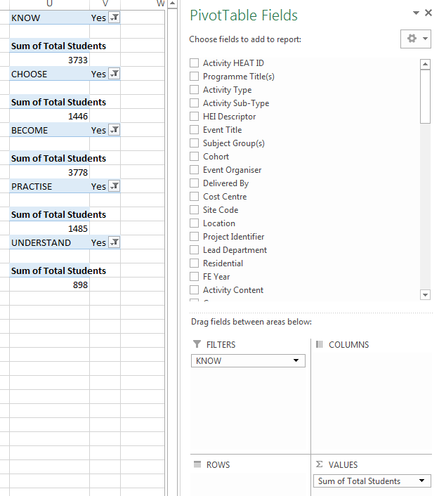
Pivot Table fields for first of the five NERUPI aims (KNOW)

- Exporting activities from HEAT and selecting the Include Students option will allow you to count the number of registered students who have participated in activities assigned to each NERUPI aim
- As students appear more than once under each activity they have participated in, the Pivot Table must be set up to calculate a distinct count of Student HEAT IDs
- The screen shot below shows five separate Pivot Tables each counting the number of unique students who have participated in an activity assigned to that NERUPI aim

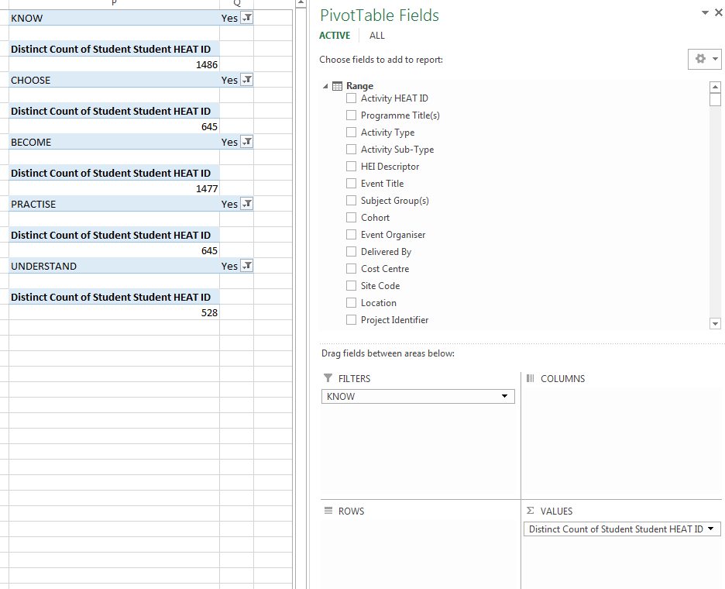
Pivot Table fields for first of the five NERUPI aims (KNOW)

Please note: The export will need to be saved as an Excel file rather than a csv file in order for the Distinct Count option to be available in the Pivot Table.

- This export will also allow you to see where the same students have participated in a range of different activities falling under different NERUPI aims

- The screenshot below lists the Student HEAT IDs and shows the number of activities they have participated in assigned to a NERUPI aim

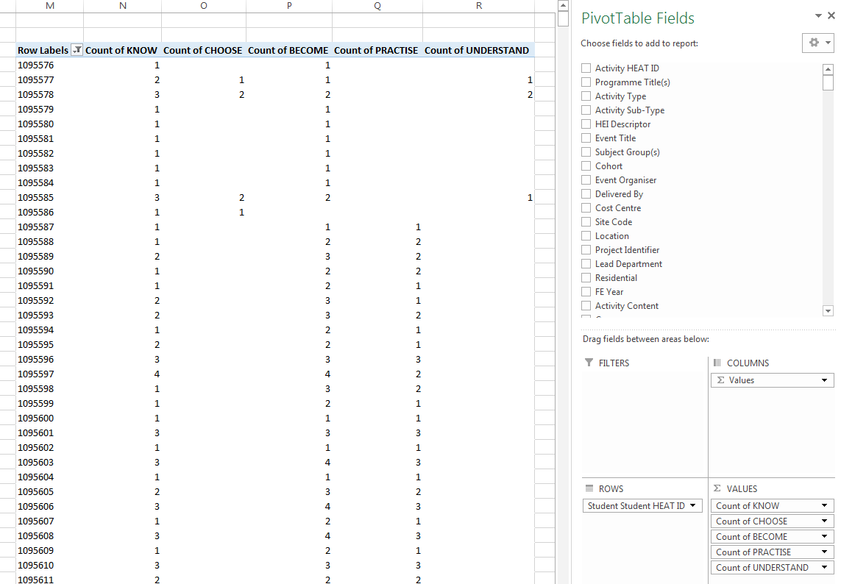

When tracking data from HESA are available, these progression outcomes can be exported from HEAT along with this export. This will allow you to examine whether progression to HE rates are higher for those who have participated in particular packages of activities.

